AguaClara Documentation
Table of Contents
AguaClara Documentation 1
Introduction 2
The Technology 2
Chemical Doser 2
Rapid Mix 3
Flocculation 4
Vertical Flocculator (Only display text below for vertical) 5
Horizontal Flocculator (only display text below for Horizontal) 5
Sedimentation 8
Inlet Channel 8
Inlet Pipe 8
Sludge Drain 8
Slopes 8
Lamella Pipe Frame 9
Lamella 9
Effluent Launder 9
Exit Channel 9
Inlet and Exit Channel Weirs 9
Inlet and Exit Channel Tanks 9
The Process and its Limitations 10
Plant Construction 10
Materials List 10
Costs and Management 10
Initial Capital Investment Costs 10
Operation, Maintenance, and Administration Costs 10
Plant Administration and Personnel 10
Experience 10
Past Plants 10

Introduction

AguaClara is a program in the school of Civil and Environmental Engineering at Cornell University that seeks to provide clean, safe drinking water to countries that limited to no access to water purification technology. The team’s goal is to feed the water through the plant without the use of electricity. This is accomplished by using gravitational potential energy.

This document provides a summary of the AguaClara processes as they apply to the enclosed plant design. This means that all mathematical values provided herein (e.g. number of flocculation tanks, distance between the centers of the orifices, etc) are tailored to this plant design, and will not necessarily apply to other AguaClara plants.

The plants are designed to remove suspended particles from the water. The units used to measure plant performance are Nephelometric Turbidity Units (NTU). The removal processes (which are described in more detail further on) are as follows:

- Addition of Aluminum Sulfate (Alum), a coagulant that causes suspended particles to stick together to form larger particles called flocs.
- Flocculation, a process that allows flocs to grow in size as they collide with each other
- Sedimentation, where the flocs are allowed to settle to the bottom of a tank as clean water flows out of the top

After particle removal is disinfection, where Chlorine is added to the water in order to destroy potentially harmful microorganisms.

The Technology

Chemical Doser

The chemical dose controller (CDC) automatically adjusts the amount of alum used to treat incoming water for any given flow rate. This allows the operator to adjust the dose in response to the turbidity.

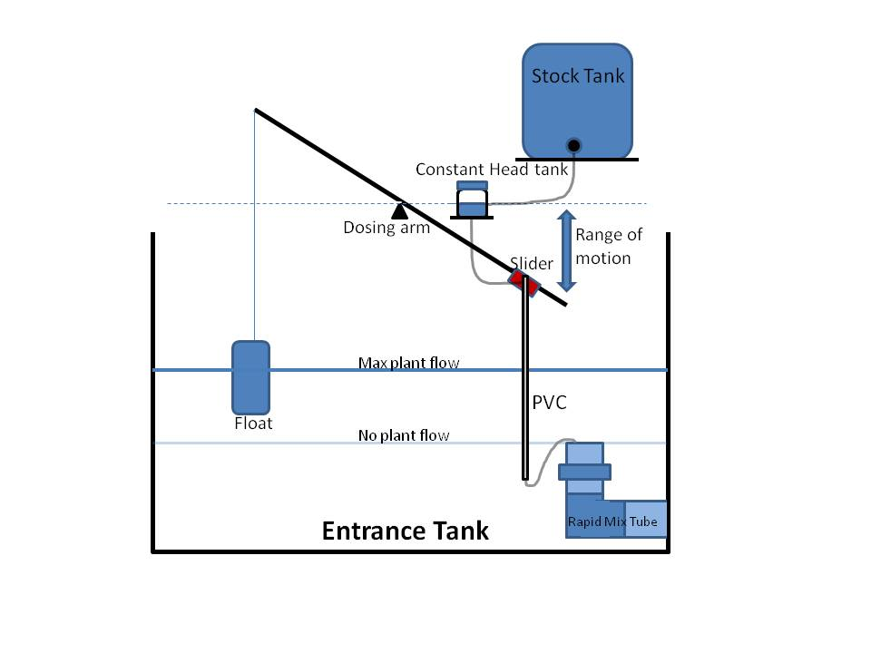
Figure 1: Non-linear Chemical Dose Controller

The CDC uses a lever arm with a float and counterweight to relate the dosing to the changes in the entrance tank water level, which is a function of the influent flow rate chosen by the operator. An increase in head loss links the chemical flow rate to the plant flow rate and the chemical dose (mg/L) will be constant as plant flow varies.

The dosing tube is designed to minimize major losses so that minor losses dominate head loss. The dosing tube is flexible to accommodate the lever arm motion and dose adjustment. There are two dosing tubes from the constant head tank to the level arm (one for each scale and one tube from the lever arm to the rapid mix tube).

Rapid Mix

Before influent water enters the rapid mixer, it must be treated with aluminum sulfate, which is often referred to as “alum”. Treatment with alum is an essential component of the water purification process, as it initiates the sequence of particle coagulation that makes flocculation effective.

Once turbid water has been treated with alum, the impurities in the water will begin to stick together, forming flocs. Only when all of the flocs are removed from the water will it truly be purified.

Describe energy dissipation here instead of flocculator or do they require different explanations?
Rapid mix serves the function of distributing alum evenly throughout the raw water. The goal is to achieve small-scale mixing on the molecular scale to ensure that the alum permeates throughout all of the water coming in to the system to allow for optimal flocculation. The rapid mix system is a pipe with two orifice interfaces. One interface is for macro-scale mixing, which will have larger diameter orifices and less energy dissipation, and the other interface for micro-scale mixing, which will have smaller diameter orifices and more energy dissipation. Orifices are circular because a circle can be drilled easily. The rapid mix program calculates the required pipe size, InnerPipeDiameter, the diameter of the macro-mixing orifice, MacroMODiameter, the diameter of the micro-mixing orifices, MicroMODiameter, and the number of micro-mixing orifices, MicroMONumber.
The diameter of the pipe used for rapid mix is determined based on the plant flow rate and constraints on the total head loss desired in the system and for the macro-mixer. The diameter is rounded to the closest available pipe size. For this function, the values for the length of the pipe, L.pipe, the minor loss coefficient, K.total, and NU, the kinematic viscosity are already defined. Headloss for the macro-mixing is set to MacroMHConstraint. The total headloss throughout the plant is set at 40 cm. Thus, the total headloss in the rapid mix portion of the plant is the difference between the total headloss and the headloss from the rest of the plant. The micro-mixing headloss is thus the difference between this value and the macro-mixing headloss.
Total Headloss for Rapid Mixer System
h.total = 40cm - (HL.Floc + HL.SedLaunder + HL.SedWeirInlet + HL.SedWeirExit)
When sizing the micro-mixing orifice, an energy dissipation of 1 W/kg must be met to ensure sufficient mixing. Based on the value determined for the micro-mixer headloss, the diameter for the micro-mixing orifice is obtained.

Flocculation

The flocculator is used to make small clumps of particles into big ones so that they can settle out more easily in the next unit process, which is sedimentation. This is most easily achieved by having particles collide with each other. Since the AguaClara plants use no electricity, this must be done by controlling the flow of the water. The water flows around a series of baffles for this to occur. The baffles are in several channels to minimize construction by maximizing shared wall space. There are N.FlocChannels channels.

The main goal of the design is to achieve the correct energy dissipation. (more detail, include equations). The target energy dissipation rate that you set for the flocculator was ED.Floc. The actual energy dissipation in each channel was ED.FlocChannel (outputs as an array! Just specify ED.Floc for all channels except last and last channel?)

Explain collision potential, include equations. The target collision potential that you set for the flocculator was CP.Floc. The actual total collision potential was CP.FlocTotal.

The height of the floc tank wall was calculated by adding the head loss of the water through the flocculator to the height of the water at the end and a freeboard height that you set as H.PlantFreeboard. The height of each floc tank wall is H.Floc.
The total width of the floc tank, including the thickness of the walls is W.FlocWithWalls. The total length of the floc tank, including the thickness of the walls is L.FlocWithWalls.

Horizontal Flocculator
In a horizontal flocculator, the baffles are staggered from side to side. The length of the baffles is L.FlocBaffle Lower. (add in width)

The baffles must be made of concrete for a horizontal flocculator because plastic baffles will not work well in the horizontal staggered positions. It would be difficult to keep them in place and have them withstand the force of water flowing around them.

The width of each channel is W.FlocChannel. It was calculated by multiplying the space between the baffles by 3.

The channels are conneced by an open space that has the same width as the space between baffles. W.FlocPort\*
Add in drain stuff when done?

Vertical Flocculator (Only display text below for vertical)

In a vertical flocculator the baffles are staggered up and down. The lower baffles start from the floor of the flocculator. They have a length of L.FlocBaffleLower. The upper baffles start a distance that is the same as the spacing between the baffles (S.FlocBaffle) higher than the floor. They have a length of L.FlocBaffleUpper.

Concrete vs. Plastic (explain) The baffle type for the plant you designed is BaffleType. For plastic baffles, in order to keep the baffles in place, slots need to be cut L.slot deep into the walls where each of the baffles are.

The width of each channel is W.FlocChannel. It is calculated by…

There are ports connecting channels that maintain the vertical flow pattern that are built into the wall of the channel. The width of the port is W.FlocPort. The height of the channel is H.FlocPort.

Horizontal Flocculator (only display text below for Horizontal)

In a horizontal flocculator, the baffles are staggered from side to side. The length of the baffles is L.FlocBaffle Lower. (add in width)

The baffles must be made of concrete for a horizontal flocculator because plastic baffles will not work well in the horizontal staggered positions. It would be difficult to keep them in place and have them withstand the force of water flowing around them.

The width of each channel is W.FlocChannel. It was calculated by multiplying the space between baffles by 3.

The channels are connected by an open space that has the same width as the space between baffles, W.FlocPort.

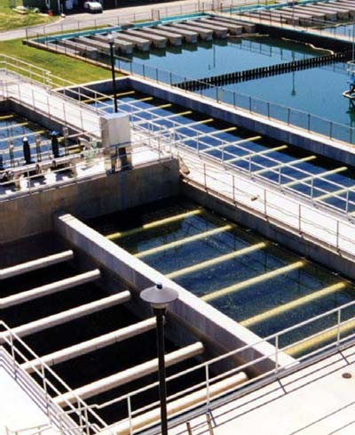
Figure 2: An example of a fully operational flocculation tank

Sedimentation

There are N.SedTanks sedimentation tanks per plant. The length of each sedimentation tank is L.Sed, its height is H.Sed, and its width is W.Sed. The height of water in the sedimentation tank is HW.Sed.The sedimentation tanks are placed side by side along their length.
Each Sedimentation tank contains N.SedBays bays, juxtaposed also along placed side by side along their length. The width of the sedimentation bay is W.SedBay.

Inlet Channel
Water flows from the flocculator to the sedimentation tank via the inlet channel. The inlet channel is a rectangular channel that runs along the combined width of the sedimentation tanks, its length is then L.Channel, its width is W.InletChannel and its height is H.InletChannel. The height of water in the inlet channel is HW.InletChannel. In the bottom of the inlet channel, there are ports that the water flows through to get into the sedimentation tank. These ports have couplings that connect the inlet channel to the manifold pipe that distributes the water evenly through the sedimentation bay. The coupling connects to a pipe of nominal diameter ND.SedManifold, which connects to an elbow, which in turn connects to the manifold pipe.

Inlet Pipe
Water enters into the bottom of the sedimentation bay via the distribution manifold pipe. The nominal diameter of the distribution manifold is ND.SedManifold. Along the bottom of the manifold are drilled ports that allow the water to flow from the manifold pipe up into the sedimentation bay. There are N.SedManifoldPorts ports, and the diameter of the ports is D.SedManifoldPort. The ports are spaced B.SedManifoldPort from the center of one port to the center of the next. The length of each manifold pipe is L.SedManifoldPipe and it is located at an elevation of Z.SedManifoldPipe from the bottom of the sedimentation tank.

Sludge Drain
Below the manifold port is the drainage channel and cover. The drain channel is a rectangular channel that runs along the length of the sedimentation bay. Its width is W.SedSludge and the depth is H.SedSludge. On top of the drain channel there is a drain cover. The drain cover is a rectangular cement board with orifices that span the length of the sedimentation bay. The width of the drain cover is W.SedDrainCover and the thickness of the drain cover is T.SedSludge. The diameter of the orifices along the drain cover is D.SedSludgeOrifice and the space from the center of one orifice to the center of the next orifice is B.SedSludgeOrifices.

Slopes
On both sides of the drain cover there is a sloped wall with a ledge on top of it. The wall's base creates the boundaries of the sludge and drain cover system. Its height is Z.SedSludge.The angle of the sloped wall is AN.SedSlope. The height of the triangular section is H.SedSlopeTriangle,and its width is W.SedInletBottom. Finally, the height of the ledge is H.SedBetween and its thickness is T.ConcreteMin.

Lamella Pipe Frame

Lamella
As water flows up through the bottom of the sedimentation bay, it flows through the lamella. The lamella are corrugated plates oriented at AN.SedPlate. Their purpose is to capture floc particles that are flowing up. Once the flocs hit the plates, the will then settle onto the lamella sheets and slide down to the bottom of the sedimentation bay. The lamella are W.Sed wide and L.SedPlate long.

Effluent Launder
Will make into more fluid paragraphs later
The number of elbows in the launder design is N.ElLaunder.
The number of orifices in each launder is N.SedLaunderOrifices.
The diameter of the sedimentation tank launder is ND.SedLaunder.
The elevation of the sedimentation tank launder is Z.SedLaunder.
The number of launders per sedimentation bay is N.SedLaunders.
The number of launders in the plant = N.PlantLaunders.
The length of the sedimentation tank launder is L.SedLaunder.
The diameter of the sedimentation tank launder orifice is D.SedLaunderOrifice.
The distance between the centers of the orifices is B.SedLaunderOrifices.

Exit Channel
The water flows from the launder into the exit channel. Like the inlet channel, the exit channel is a rectangular channel that is W.ExitChannel wide and the height of the exit channel is H.ExitChannel. The channel thickness is T.ChannelWall.

Inlet and Exit Channel Weirs

In both the inlet channel and exit channel there are weirs that regulate the water height in the plant. There are two possible weir designs:
- The weirs span the length of the entire inlet or exit channel, and run parallel to the channel.
- The weirs span the width of the channel and run perpendicular to the channel.
In our case, the weirs behave as described in (1).
By calculating the headloss over the weir given the plant flow rate, the height of the weir can be determined. The height of the water in the plant is then equal to the height of the water flowing over the weir. The weir in the exit channel regulates the height of the water in the sedimentation tank (and thus the rest of the plant) during normal plant operation. Its height is H.SedExitWeir and its width is W.SedExitWeir. When the water coming from the flocculator is not suitable for the flocculator, the water can be dumped before going into the sedimentation tank. In this case the weir in the inlet channel regulates the height of the water in the flocculator. The width of the inlet weir is W.SedInletWeir and the height of the inlet channel weir is H.SedInletWeir.

Inlet and Exit Channel Tanks
The inlet tank provides a path for water when flocculation fails and the water cannot enter the sedimentation tank. The tank cantilevers off the side of the sedimentation tank. The dimensions of the tank are ichanneltank.dim. The tank contains a pipe which will connect to an exit channel for wastewater. This pipe has nominal diameter ND.PltWeir and length inletwierpipe.length. The pipe has a tee on it with the same diameter. The tee takes in water from the inlet tank and the connecting pipe from the exit tank and sends it to waste.

The exit tank takes water from the exit channel after it has gone through the sedimentation tank. The dimensions of the exit tank are stored in echanneltank.dim. The exit tank has two pipes: one which sends clean water to the distribution center and one which sends water through a connecting pipe to the inlet tank pipe and then out to waste. Both pipes have nominal diameter ND.PltWeir and length exitweirpipe.length. The connecting pipe from the exit tank pipe to the inlet tank pipe has the same diameter and length connectingpipe.length .

Limitations

Though the AguaClara plants do a great job purifying water in areas that previously had minimal access to such technologies, they have inherent limitations. Some of the main limitations are:
- Bound on lowest turbidity – Because no electricity is used in any of the Aguaclara plant processes, turbidity can only be removed to a certain extent. Currently, the lowest turbidity level that we have registered after treatment in an Aguaclara plant is 0.96 NTU (at the Agalteca plant). In comparison, the United States requires all drinking water to have a turbidity level of no more than 0.3 NTU.
- Incomplete water purification – Aguaclara plants do a good job removing turbidity, and they remove a good portion of biological contaminants via chlorination. However, they do not achieve full removal of chemical contaminants or heavy metals. A far more expensive and advanced technology would be required to achieve removal of such contaminants.
- Operator necessary – In order to ensure that our plants continue to run properly, an operator needs to be hired to restock the plant, change the dosages, and perform maintenance (remove settled flocs from the sedimentation plates, etc). This results in a substantial recurring cost beyond the plant construction costs.

Plant Construction

Materials List

Costs and Management

Initial Capital Investment Costs

Operation, Maintenance, and Administration Costs

Plant Administration and Personnel

Experience

Past Plants

A complete list of the Aguaclara plants that have been constructed can be found on this web page: https://confluence.cornell.edu/display/AGUACLARA/Project+Sites
This site contains links to each plant’s wiki page, as well as a map showing the locations of the plants relative to one another in Honduras.

